What to bring along: (Those in red are important)

- Open minds

- Good (food) mood

- Rain gear

- Phone and charger

- Medications and recipes for personal use

- Toilet articles (soap, shampoo etc.)

- Towel and sheets/sleepingbag

- Comfortable and also warm clothing

- Enough spare clothes ( no loundry access)

- Clean underwear and socks for each day
- Pyjama

- Hat/scarf/cap (cloves)

- Swimsuit

- Jacket (light)

- Sporty clothes (football, beachvolley, trekking)

- Drinking bottle

- Two pairs of shoes (other ones for sport/trekking)

- sandals/crocs for campbase

- Small packbag (for day trips/handluggage)

- Pocketmoney (higher prices than at home)

- Sunlotion and mosquito repellent

- Sunglasses

- PASSPORT and copy for your own leader

- Good and comfortable shoes and clouds for Hikingtrip. You may be a little wet

- Travel insurance document

  - European health card

- Optional:

  - earplugs
  - some fun games
  - music (memorystick, mp3 player)
  - camera and charger
  - traditional sweets

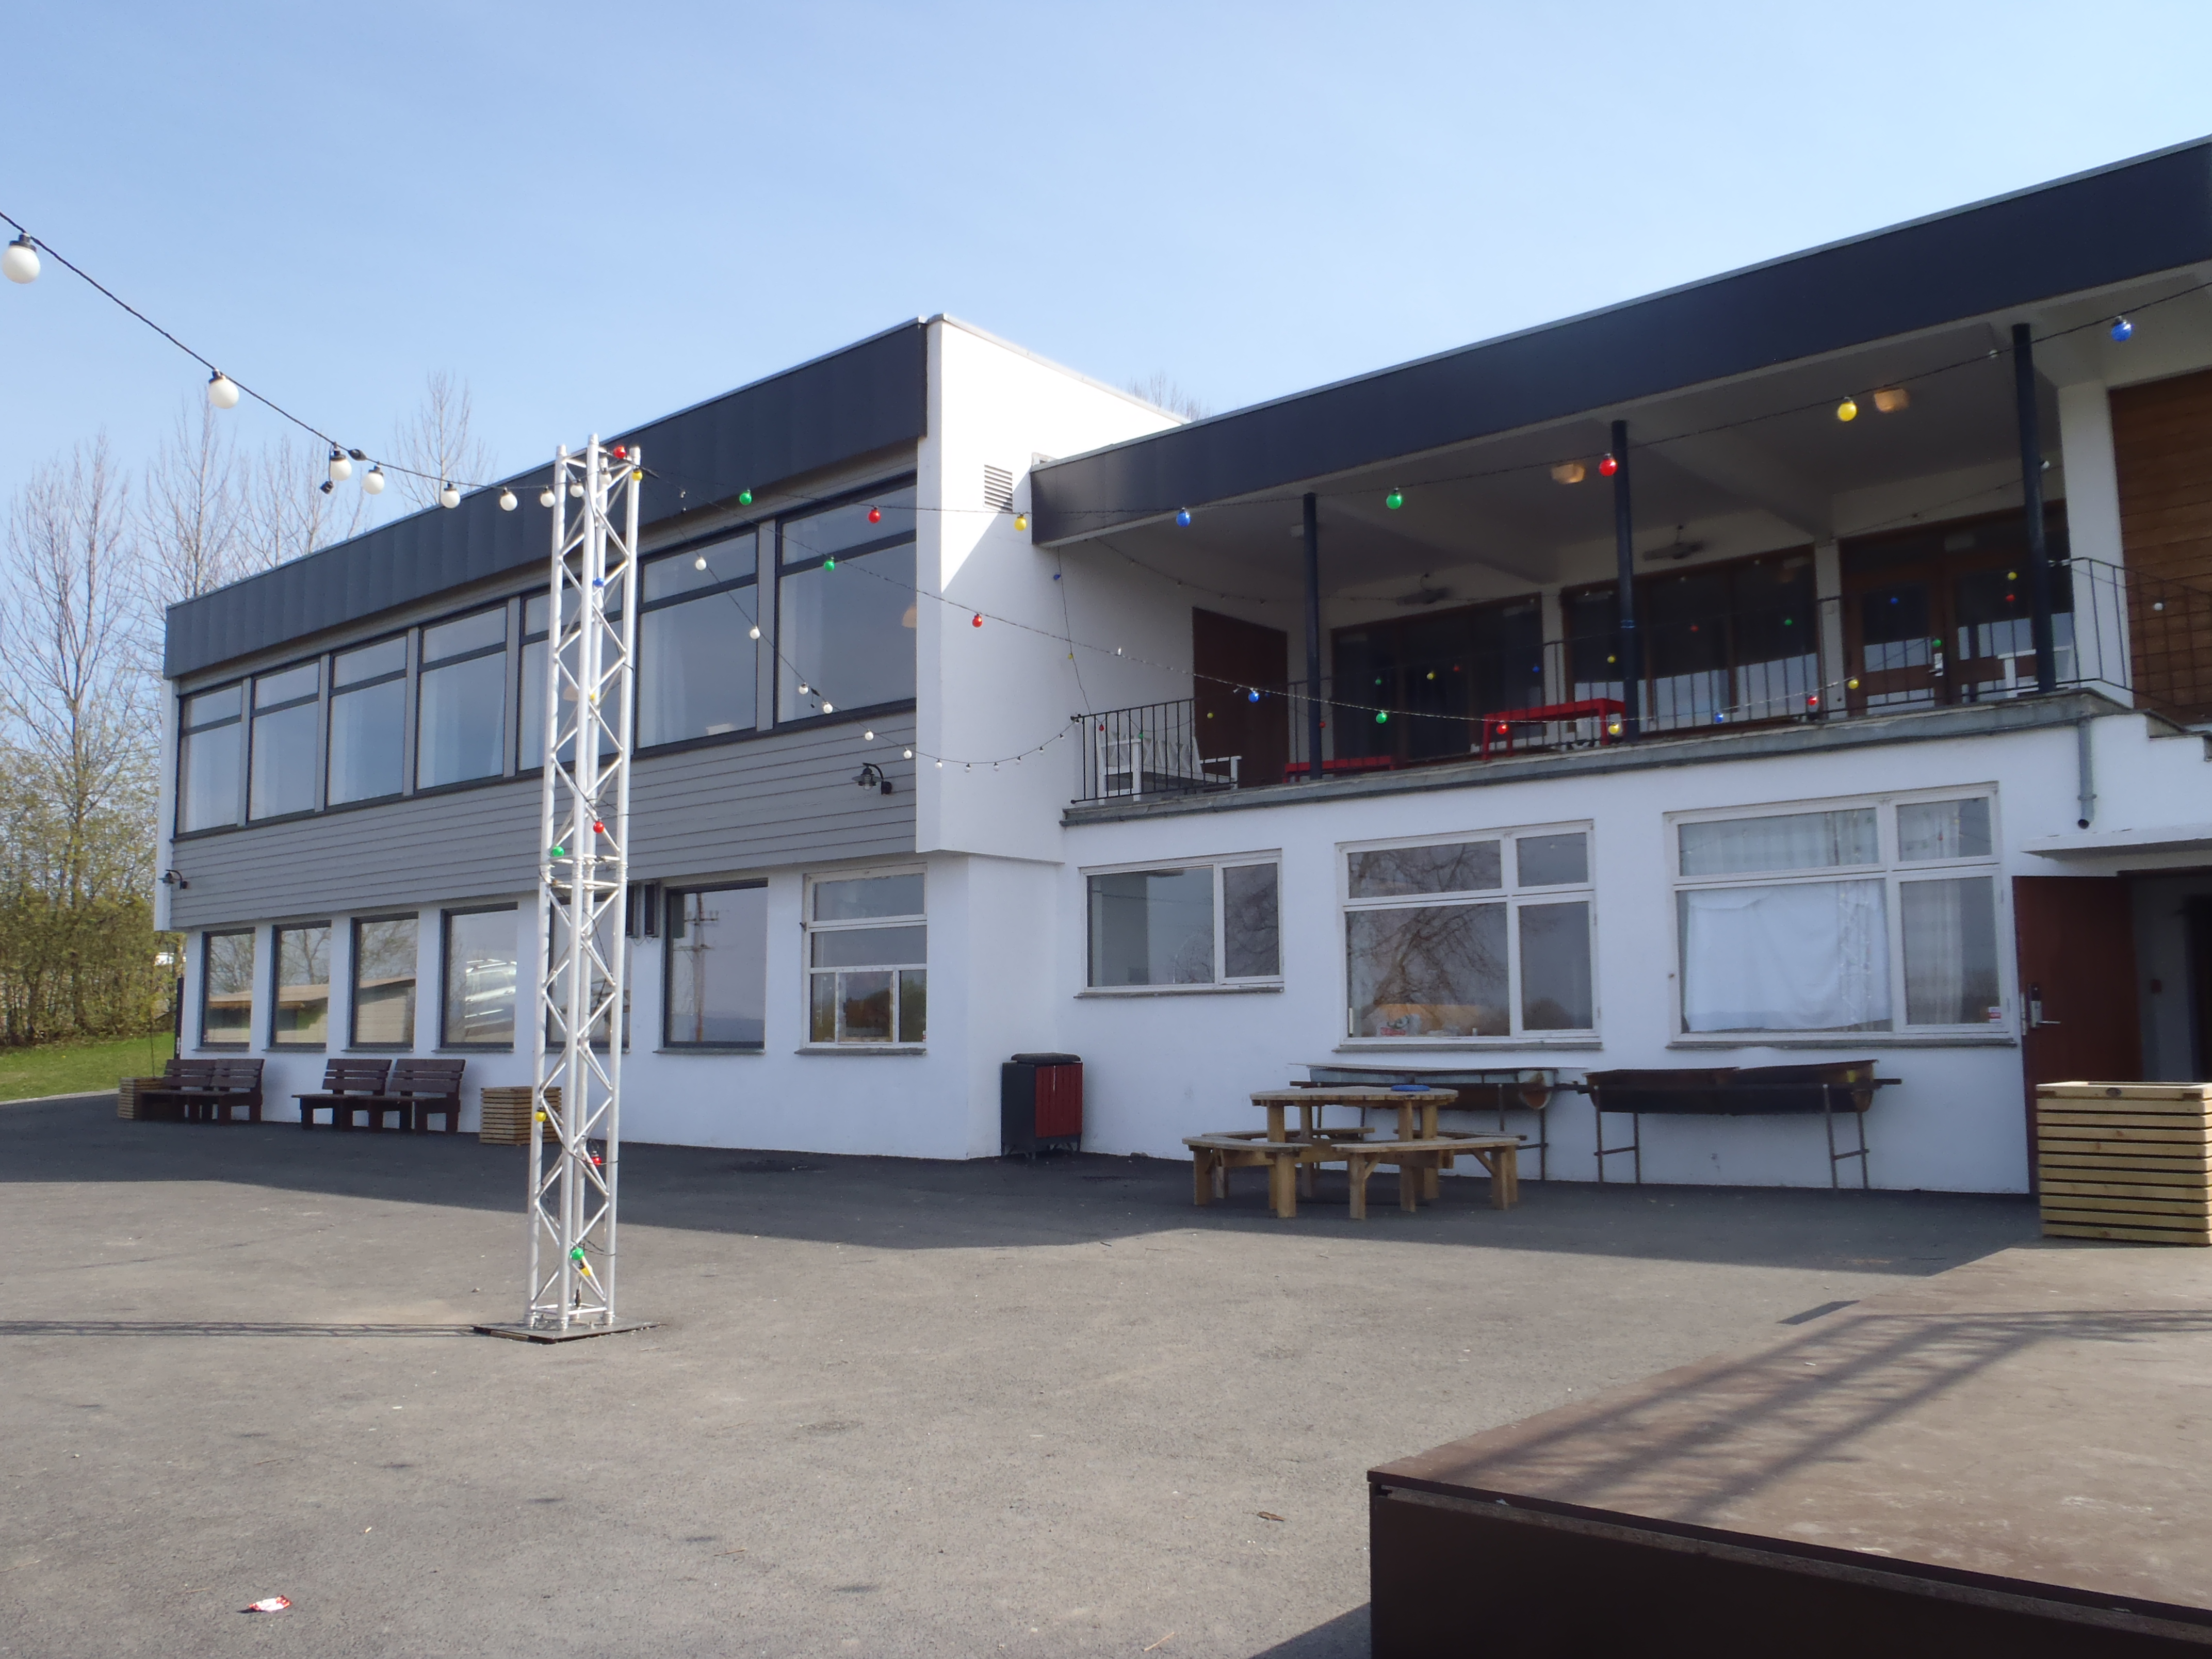
Campbase:



